Linux Basics Assignment –
1.Create a directory named test_dir using mkdir.

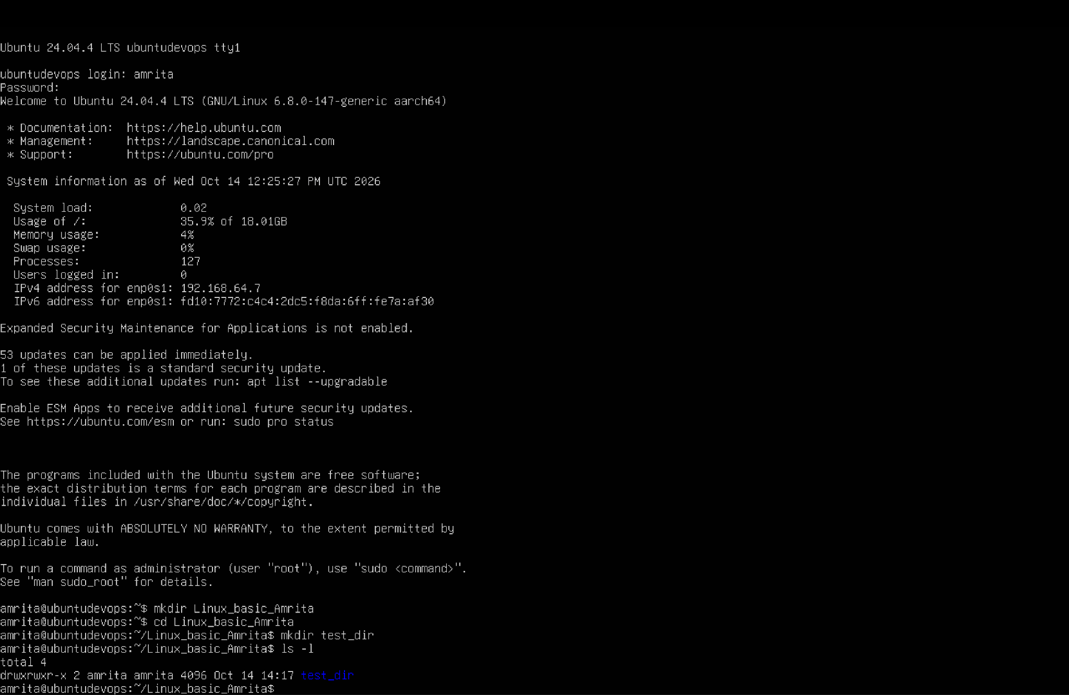

2.Inside test_dir, create an empty file called example.txt.
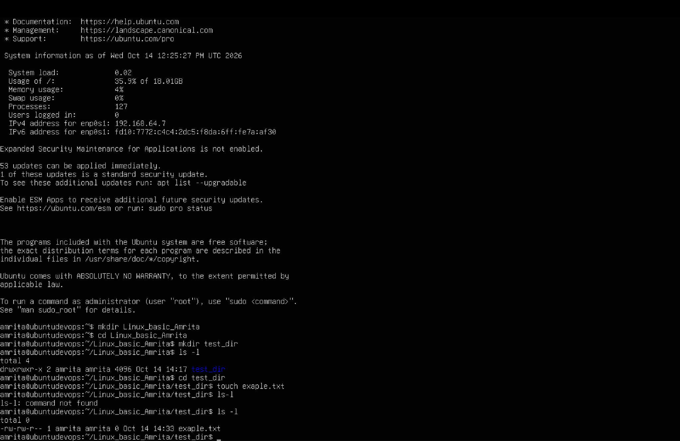

3. Rename example.txt to renamed_example.txt using mv.
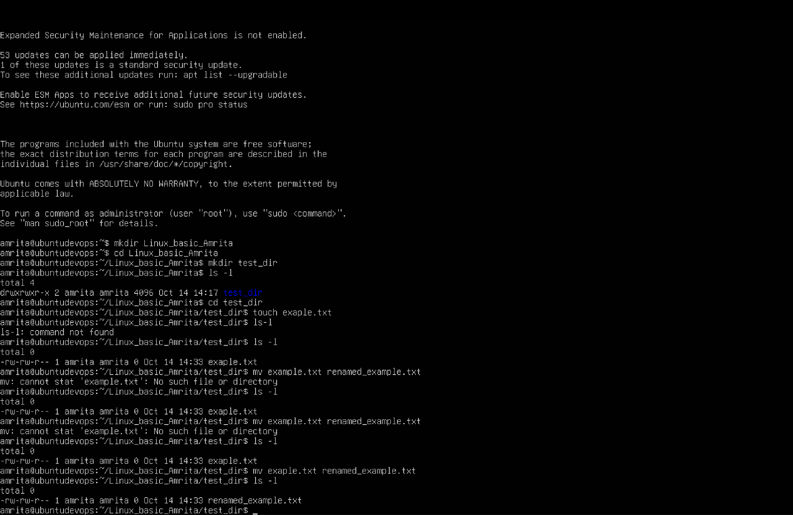

2. Viewing File Contents
1.Use cat to display the contents of /etc/passwd.
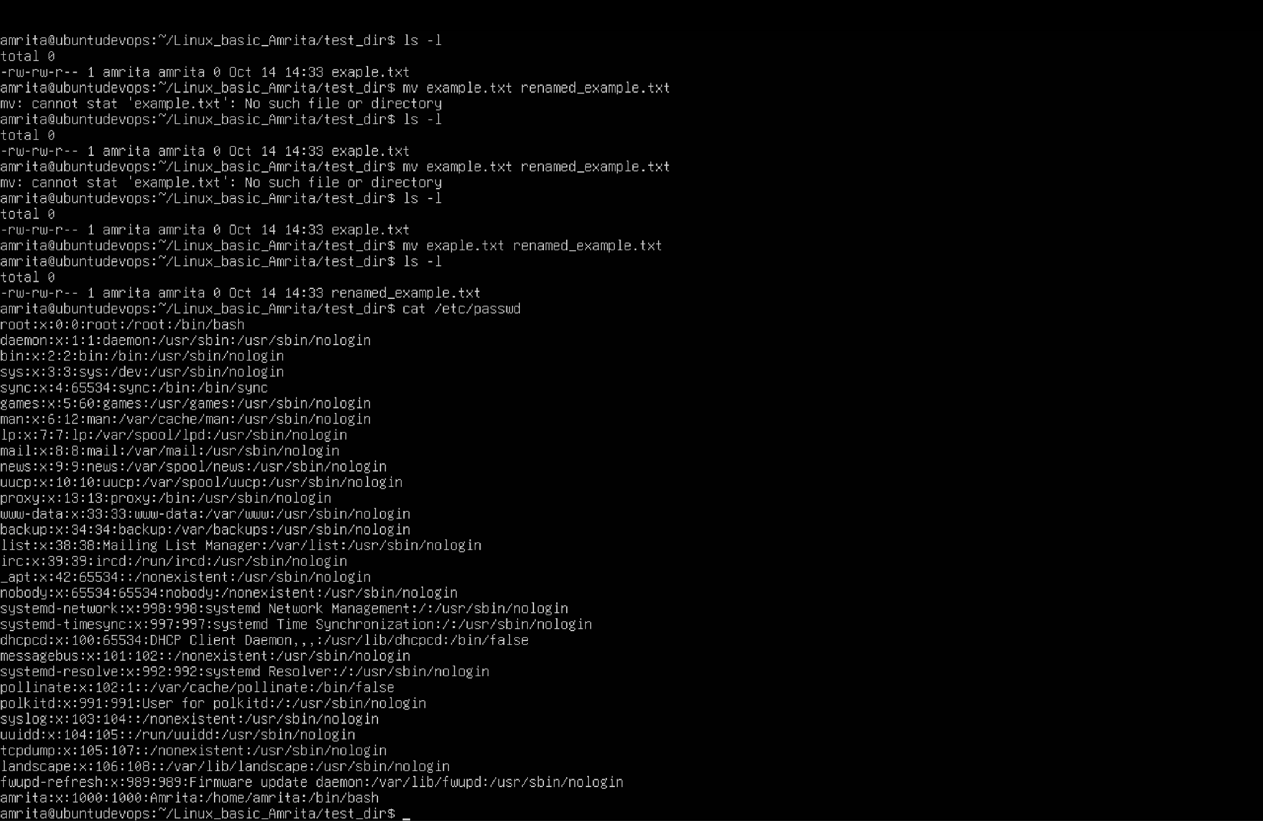

2.Display only the first 5 lines of /etc/passwd using head.
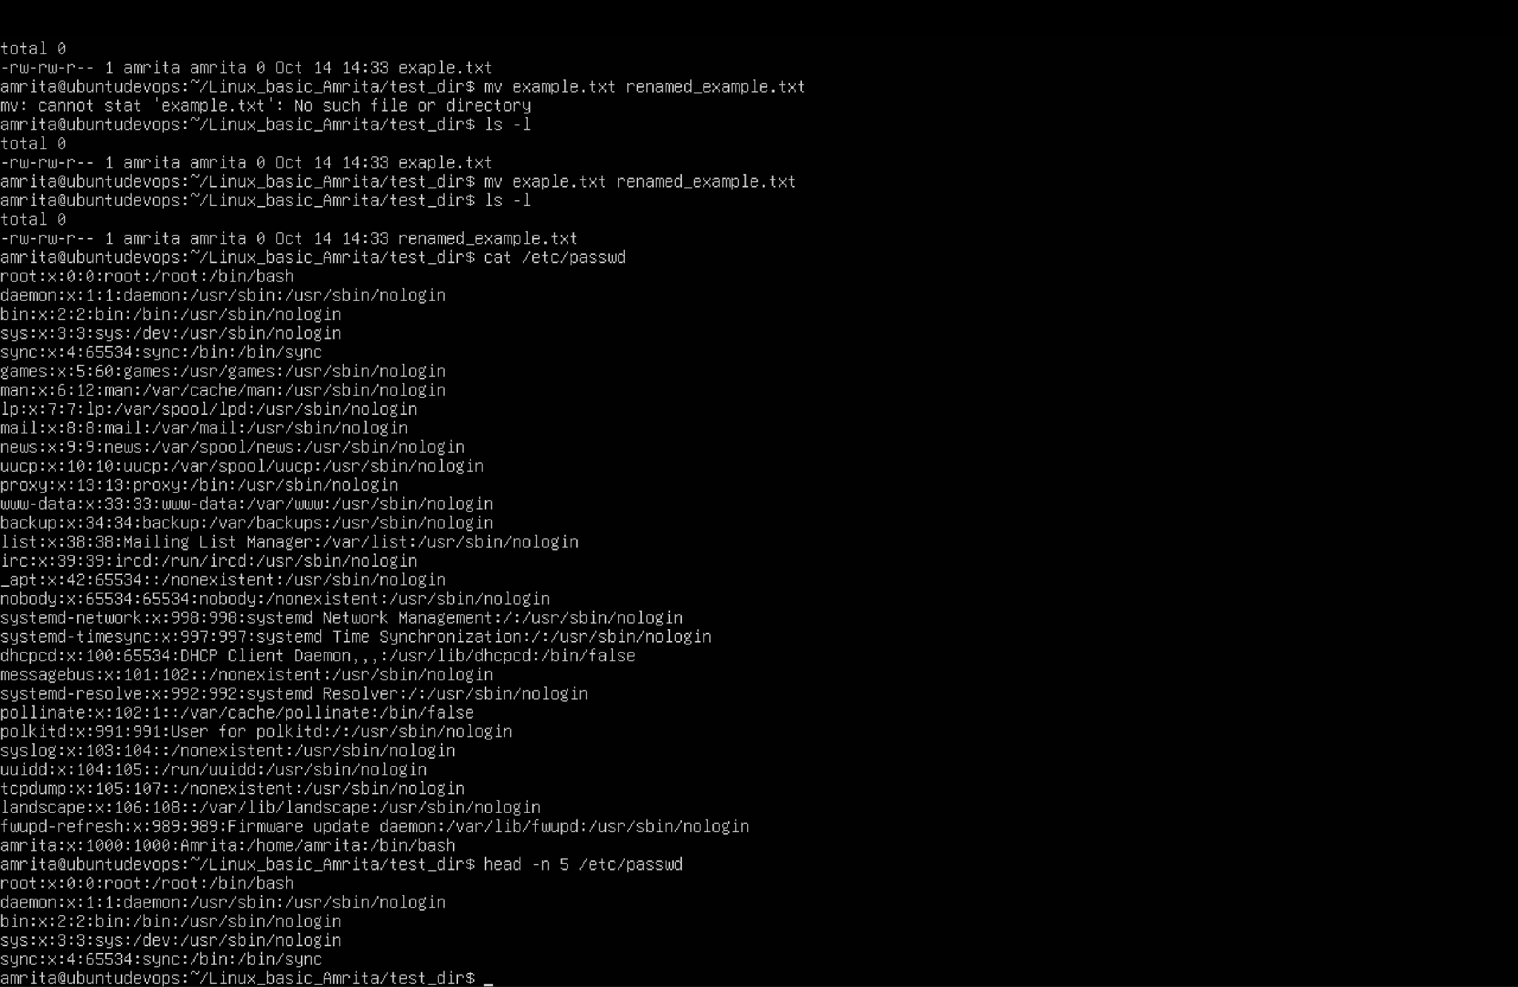

3.Display only the last 5 lines of /etc/passwd using tail.
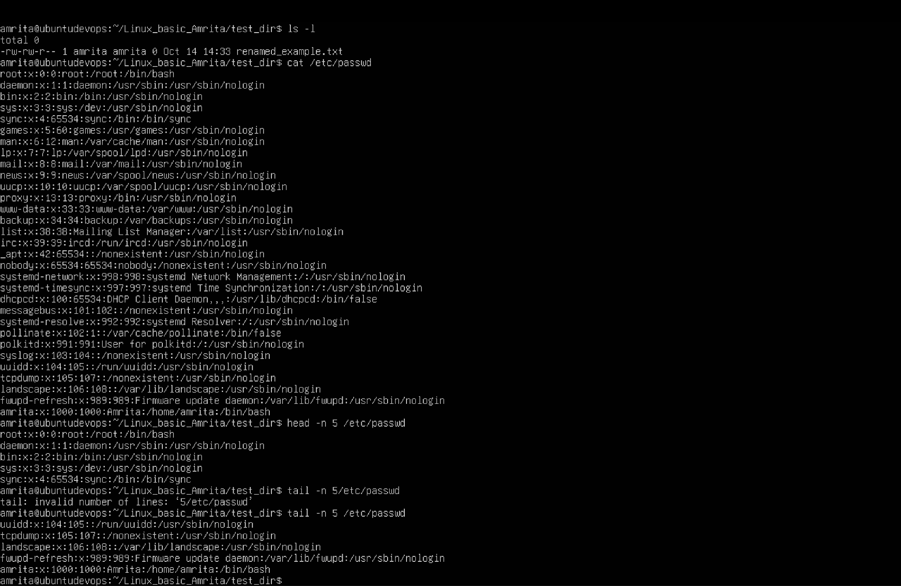
3. Searching for Patterns
- Use grep to find all lines containing the word “root” in /etc/passwd.
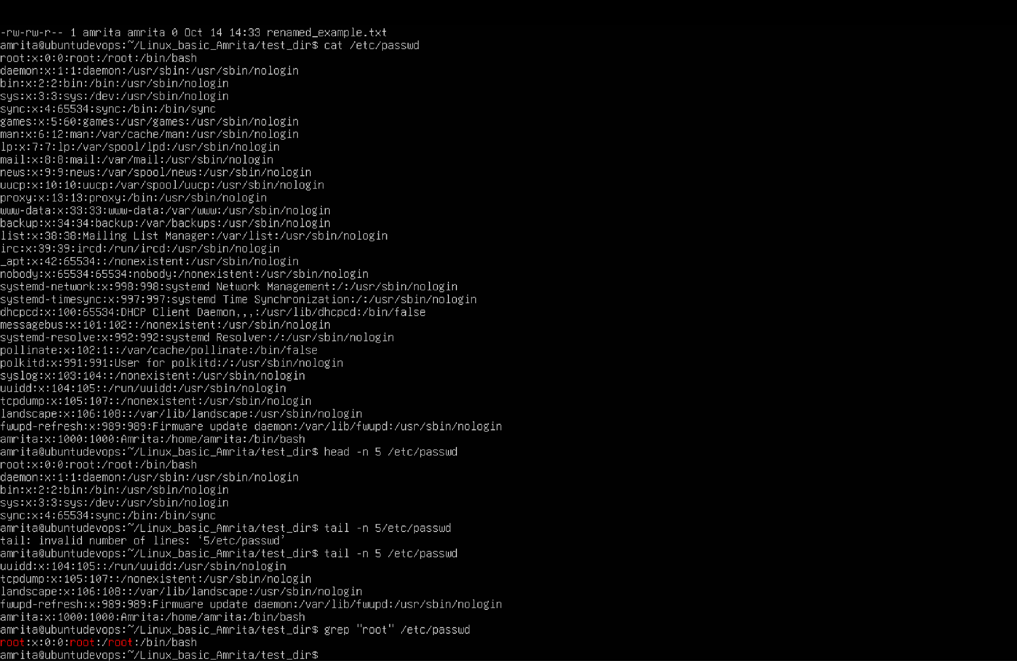

4. Zipping and Unzipping
- Compress the test_dir directory into a file named test_dir.zip using zip.
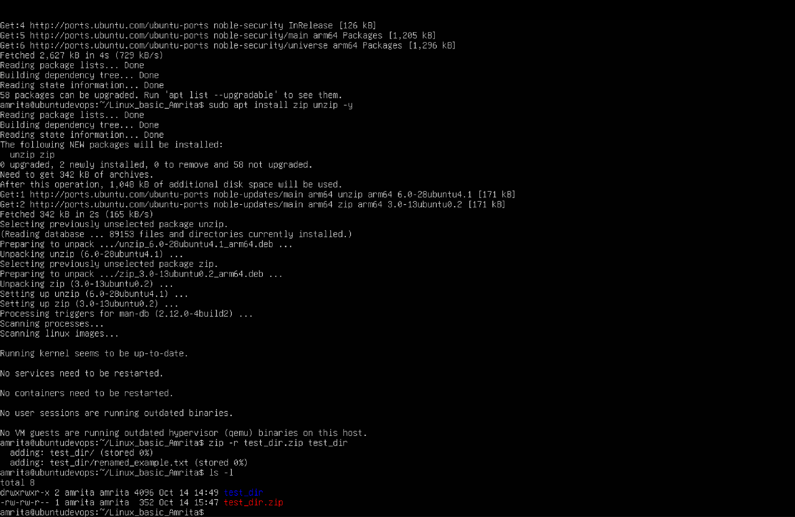

- Unzip test_dir.zip into a new directory named unzipped_dir.
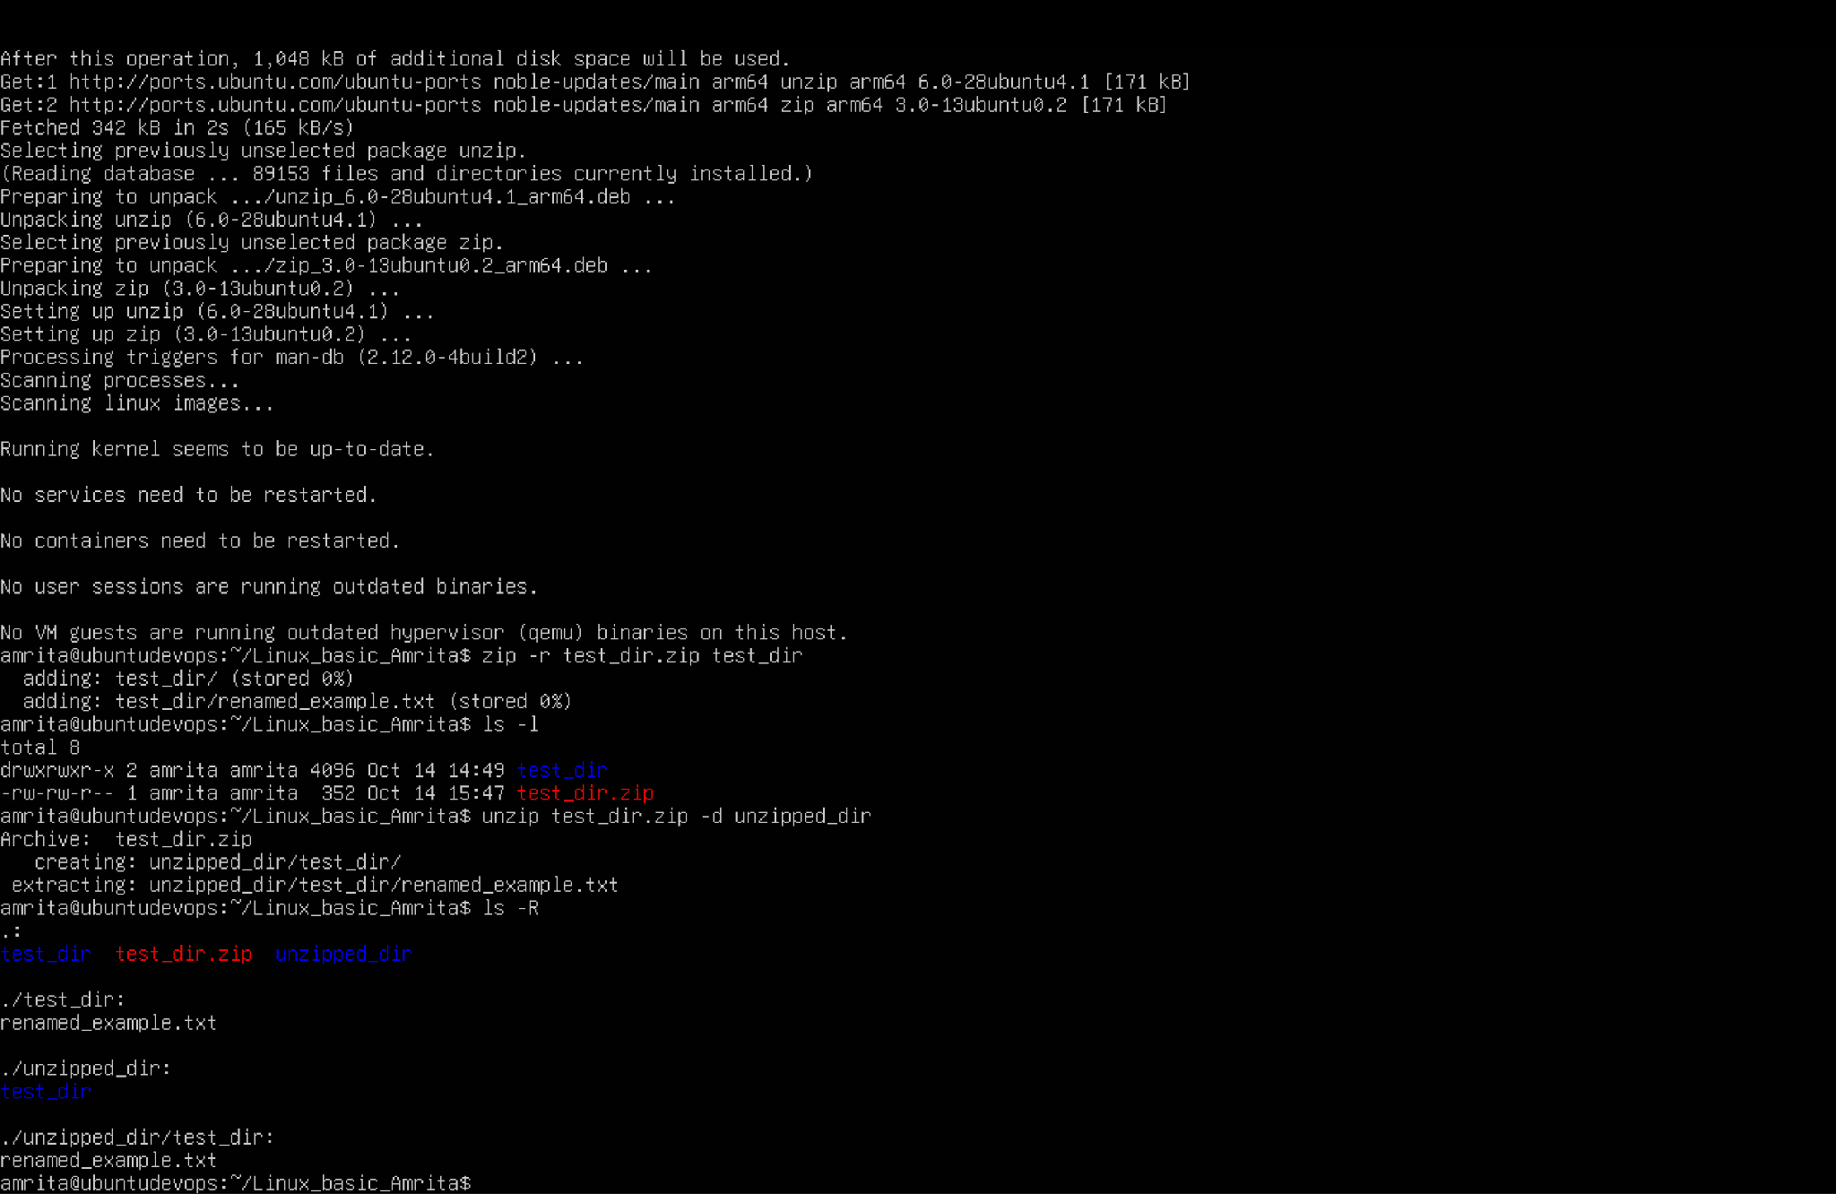

5. Downloading Files
- Use wget to download a file from a URL (e.g., https://example.com/sample.txt).
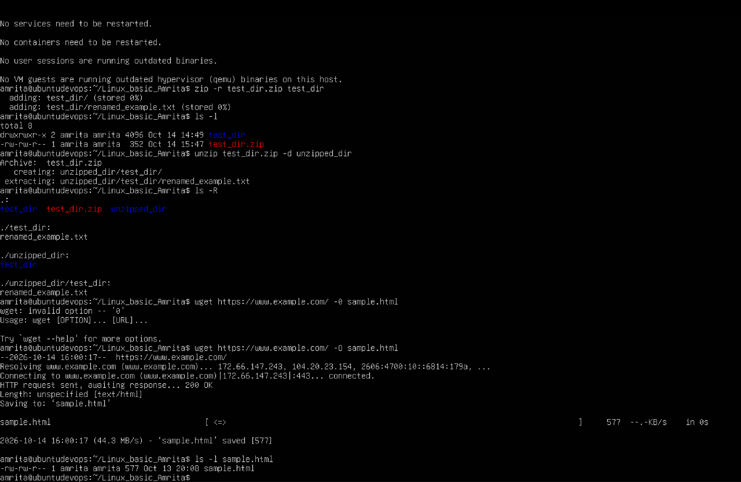

6. Changing Permissions
- Create a file named secure.txt and change its permissions to read-only for everyone using chmod.
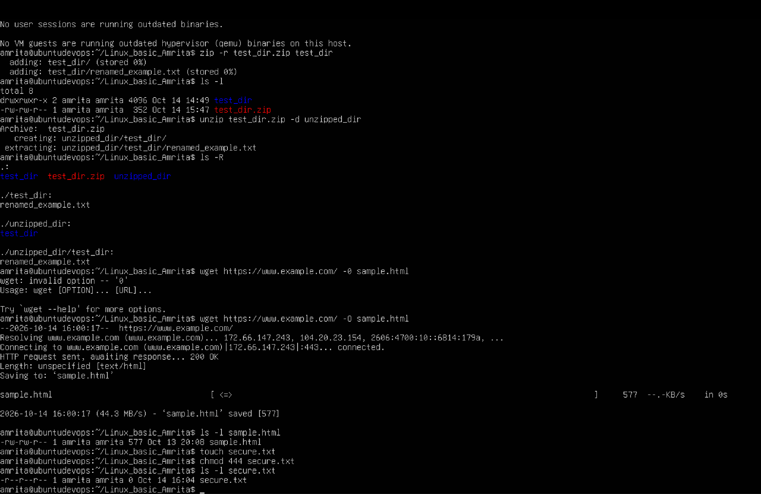

7. Working with Environment Variables
- Use export to set a new environment variable called MY_VAR with the value “Hello, Linux!”.
